SOFTWARE DESIGN DOCUMENT (SDD)

Hotel Reservation System (HMS)
1. DOCUMENT CONTROL
Item | Details
Project Name | Hotel Management System
Version | 1.0
Author | Saksham Omar
Date | 07-01-2026
Status | Final

2. PURPOSE OF THE DOCUMENT
This Software Design Document (SDD) provides a detailed description of the architecture, design decisions, component structure, service responsibilities, APIs, data design principles, security considerations, and non-functional requirements of the Hotel Reservation System.
The purpose of this document is to::
- Serve as a blueprint for implementation
- Ensure clear separation of responsibilities across microservices
- Capture real-world hotel business rules
- Maintenance & enhancement planning
- Enable scalability, maintainability, and security
- Act as a reference for:
- Developers
- Reviewers
- Interview discussions
- Future enhancements and maintenance
This document follows enterprise-grade software engineering practices and is aligned with industry expectations for distributed systems.

3. SYSTEM OVERVIEW

3.1 Business Objective
The Hotel Reservation System is designed to support a hotel chain operating across multiple cities and properties. The system aims to replace manual or semi-automated reservation processes with a centralized, secure, and scalable digital platform.
The system enables:
- Real-time room availability search
- Online hotel booking and cancellation
- Accurate check-in and check-out workflows
- Secure user authentication and role-based access
- Operational visibility through reports and notifications
- High concurrency handling without double booking

3.2 High-Level Features
- User authentication and authorization (JWT-based)
- Hotel and room category management
- Room availability tracking by date range
- Reservation lifecycle management
- Asynchronous notifications
- Reporting using CQRS-style read models
- Redis-backed concurrency-safe availability

3.3 User Roles
- Admin: Manages system-wide configurations and users
- Hotel Manager: Manages hotel rooms and availability
- Receptionist: Handles check-in and check-out operations
- Guest: Searches rooms and makes reservations

4. ARCHITECTURE OVERVIEW (HLD)
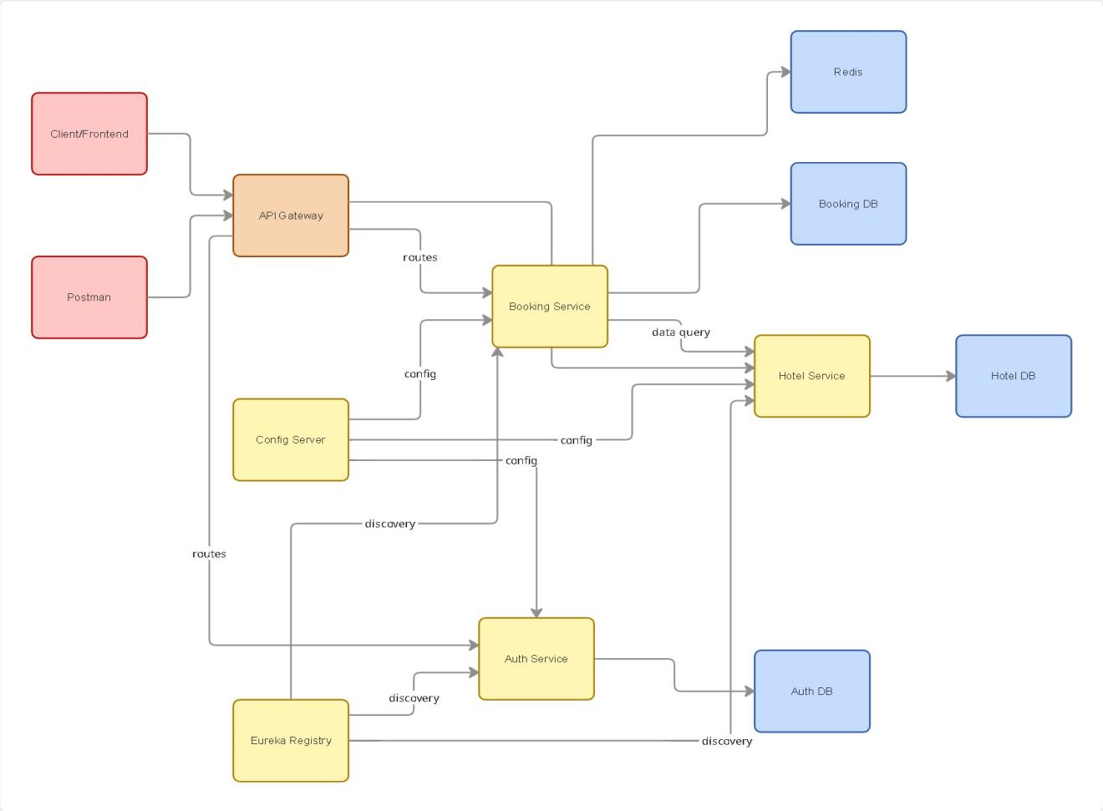
ER Diagram and relationships 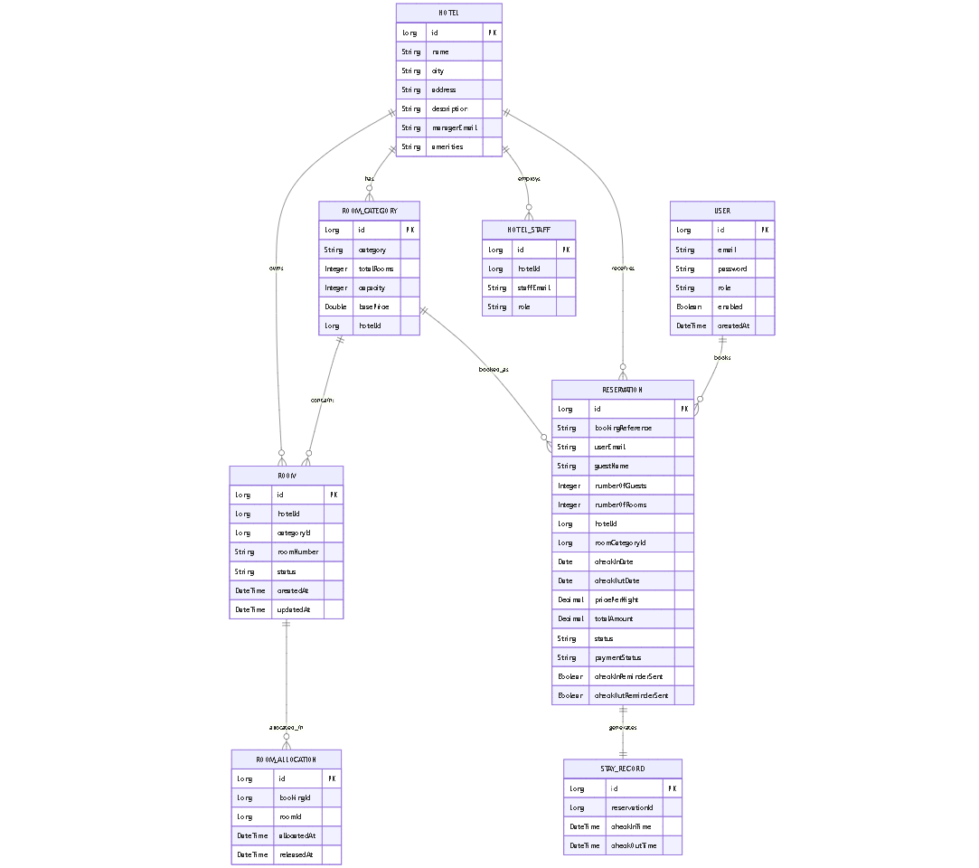

4.1 Architecture Style

The system follows a Microservices Architecture with the following characteristics:
- Each business capability is implemented as an independent service
- Services communicate via REST APIs and asynchronous events
- Centralized configuration and service discovery
- Stateless backend services
- Cloud-ready and container-friendly design

4.2 Core Components

4.2.1 Platform / Infrastructure Services
(a) API Gateway
- Single entry point for all client requests
- Routes requests to appropriate microservices
- Performs JWT validation and request filtering
(b) Config Server
- Centralized external configuration management
- Environment-specific configuration support
(c) Service Registry
- Service discovery using Eureka
- Enables dynamic service lookup and load balancing

4.2.2 Business Microservices
- Auth Service
- Hotel Service
- Availability Service
- Booking Service
- Notification Service (Asynchronous)
- Reporting Service (CQRS-based)

4.3 High-Level Interaction Flow
(a) Client sends request to API Gateway
(b) API Gateway validates JWT and routes request
(c) Auth Service manages identity and access control
(d) Booking Service orchestrates reservation workflows
(e) Availability Service validates and locks room availability
(f) Hotel Service provides room and pricing metadata
(g) Notification Service sends async alerts
(h) Reporting Service consumes events for analytics
Note: Each microservice owns its database and enforces business rules within its service boundary.
- TECHNOLOGY STACK

The Hotel Reservation System is built using a modern, production-ready technology stack aligned with current enterprise standards. The chosen technologies ensure scalability, security, maintainability, and ease of deployment in cloud-native environments.

Backend
- Java 17+
- Spring Boot 3.x
- Spring Web (REST APIs)
- Spring Data JPA & Hibernate
- Spring Security
- Spring Cloud Components
- OpenFeign / RestTemplate

Frontend
- Angular
- Angular Material
- TypeScript
- HttpClient & Interceptors

Database
- Relational Database (MySQL / PostgreSQL)
- ACID Compliance
- Strong consistency for transactional operations
- Database per Microservice Pattern
- Each microservice owns its schema
- No shared databases between services
- MongoDB for event-driven workloads like notifications

DevOps
- Docker
- Docker Compose
- Jenkins
- SonarQube

Testing
- JUnit 5
- Mockito
- Spring Boot Test
- Postman
Note: Each microservice owns its database and enforces business rules strictly within its service boundary.
- MICROSERVICES DESIGN

This section provides a detailed description of each business microservice in the Hotel Reservation System. Each microservice is independently deployable, owns its database, and encapsulates its business rules. The design strictly follows single responsibility, database-per-service, and loose coupling principles.
  - Auth Service
6.1.1 Purpose
The Auth Service is responsible for authentication, authorization, and identity management across the system. It acts as the central security authority.
6.1.2 Responsibilities
- User registration and login
- Role-based access control (RBAC)
- JWT token generation and validation
- Password encryption and credential validation
6.1.3 Models
(a) Role Enum - ADMIN, MANAGER, RECEPTIONIST, GUEST
(b) User - Email, Password, Role
6.1.4 Key APIs (High Level)
POST /auth/register

Payload:
{
"email": "guest2@gmail.com",
"password": "abcdpqrs"
}

- Role - Guest as default
- Admin seeding possible through backend only.

POST /auth/login

Payload:
{
"email": "guest2@gmail.com",
"password": "abcdpqrs"
}

POST /auth/internal/create-manager

Payload:
{
"email": "Manager@gmail.com",
"password": "abcdpqrs"
}

- Flow- ADMIN creates the hotel and at the time of creation of the hotel, he also assigns a manager with each hotel, this api makes sure that the email associated with that hotel, exists in the auth_db and has the role as MANAGER.
- Communication : Hotel-service ----> Auth-service (through OpenFeign).

POST /auth/internal/receptionists
Payload:
{
"email": "Receptionist@gmail.com",
"password": "abcdpqrs"
}
- Flow : MANAGER can use this api to create the RECEPTIONIST associated to that respective hotel (auth-service will set the role for that email as RECEPTIONIST).
- Communication : Hotel-service ----> Auth-service
- Relationship : One hotel can have many receptionists.
6.1.5 Database
- Users
- Roles
- User-role mappings
- Authentication metadata
6.1.6 Business Rules
- Email must be unique
- Passwords must be encrypted (BCrypt)
- Only ADMIN users can manage roles
- JWT is mandatory for protected APIs
  - Hotel Service
6.2.1 Purpose

The Hotel Service manages hotel master data and room configuration. It provides reference data for other services.
6.2.2 Responsibilities
- Manage hotels (name, city, address)
- Manage room categories (Single, Double, Deluxe, Suite)
- Define room capacity
- Maintain base pricing per room category
6.2.3 Models
(a) Hotel - Name, City, Address, Description, ManagerEmail, Amenities, RoomCategories (One hotel can have many room categories) .
(b) RoomCategory - Category, TotalRooms, Capacity, BasePrice, HotelID
(c) HotelStaff - HotelID, StaffEmail, Role (RECEPTIONIST as per now).
6.2.4 Key APIs (High Level)
Public API:
GET /hotels
GET /hotels/search - search hotels by city
GET /hotels/{hotelID} - search hotel by hotelID
GET /hotels/{hotelID}/categories - get room categories of the hotel

Protected API:
POST /hotels (ADMIN-RBAC)

Payload:
{
"name": "Taj Hotel",
"city": "Hyderabad",
"address": "Hitech city, Hyderabad",
"description": "Luxury hotel in city center",
"managerEmail": "manager.taj@hotel.com",
"amenities": ["WiFi", "Parking", "Pool"],
"roomCategories": [
{
"category": "DELUXE",
"totalRooms": 10,
"capacity": 2,
"basePrice": 3500
},
{
"category": "STANDARD",
"totalRooms": 20,
"capacity": 2,
"basePrice": 2000
}
]
}

PUT /hotels/{hotelID}

- Update hotel
- ADMIN/MANAGER

POST /hotels/{hotelID}/categories

- add room category to the hotel
- ADMIN/MANAGER

Payload:
{
"category": "SUITE",
"totalRooms": 5,
"capacity": 4,
"basePrice": 7000
}

PUT /hotels/categories/categoryID

- update the category of the hotel
- ADMIN/MANAGER

POST /hotels/{hotelID}/receptionists

- add the existing RECEPTIONIST to the associated hotel
- MANAGER of the hotel

GET /internal/hotels/categories/{categoryID}

- Flow : used by booking-service to check the number of rooms in each category
- Communication : Booking-service ----> Hotel-service
6.2.5 Database
- Hotels
- Room Categories
6.2.6 Business Rules
- Each hotel must have at least one room category
- Base price must be greater than zero
- Only ADMIN or MANAGER can modify data

6.3 Booking Service
6.4.1 Purpose

The Booking Service manages the reservation lifecycle and orchestrates interactions with Availability, Hotel, and Payment systems.
6.4.2 Responsibilities
- Create and manage reservations
- Validate booking dates
- Handle booking status transitions
- Manage check-in and check-out
- Calculate stay duration and total amount
- Availability of rooms
- Handle report generation for admin and manager dashboards
6.4.3 Key APIs (High Level)
POST /bookings
GET /bookings/{id}
PUT /bookings/{id}/cancel
PUT /bookings/{id}/check-in
PUT /bookings/{id}/check-out
6.4.4 Database
- Bookings
- Booking guests
- Booking status history
6.4.5 Business Rules
- Availability must be confirmed before booking
- Invalid status transitions are rejected
- Check-in date must match booking start date
- Check-out cannot occur before check-in

6.5 Notification Service
6.5.1 Purpose
The Notification Service handles asynchronous, event-driven notifications to users without blocking core business workflows.
6.5.2 Responsibilities
- Consume domain events (booking created, confirmed, cancelled, checked-in, checked-out)
- Send notifications via email/SMS (basic simulation)
- Track notification delivery status
6.5.3 Key APIs (High Level)
Event consumer (message broker)
POST /notifications/internal/send
6.5.5 Business Rules
- Notification failures must not impact booking flow
- Failed notifications can be retried asynchronously
- Notifications are best-effort, not transactional

